Ideation Phase
Define problem and statements
Date | 1November2025
Team ID | NM2025TMID02619
Project Name | Calculating family Expenses using service now
Maximum marks | 2Marks

Customer Problem Statement Template:

Families often struggle to efficiently track and analyze their monthly expenses. Managing multiple spending sources .such as groceries, rent, utilities, education, and entertainment becomes time-consuming and error-prone when done manually or using traditional spreadsheets. This lack of a centralized system leads to poor financial visibility and difficulty in maintaining budgets
In many cases, families are unable to identify overspending trends or calculate total expenses accurately at the end of each month. The absence of automation and visual insights results in confusion, missed payments, and reduced savings potential.
They need a ServiceNow-based expense management solution that allows each family member to log their individual expenses while automatically calculating totals, generating visual reports, and sending notifications when budgets exceed limits.
This solution will enhance financial transparency, promote better budgeting habits, and provide real-time insights into spending patterns — ultimately improving financial discipline and decision-making within the family.
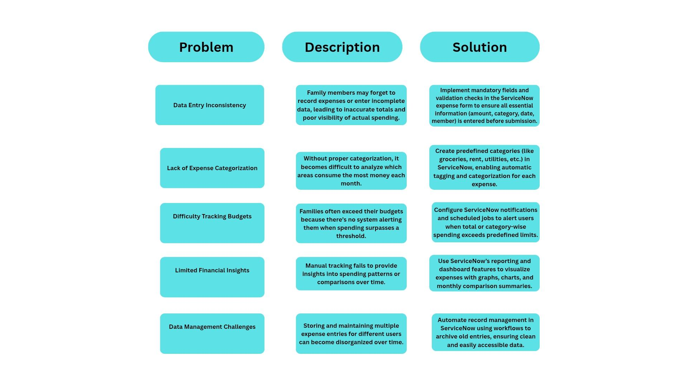
Reference: https://www.canva.com/design/DAG3ioIcIZQ/ZqUHDKqBkBZaDTjTPh2Z7Q/edit?utm_content=DAG3ioIcIZQ&utm_campaign=designshare&utm_medium=link2&utm_source=sharebutton

Define the Problem Statements

Problem Statement (PS) | I am (Customer) | I’m trying to | But | Because | Which makes me feel
Ps-1 | A Family Member | Record my daily expenses | it takes too long and sometimes gets missed | there is no easy or automated way to log expenses | frustrated and disorganized
Ps-2 | A Parent/Household Manager | Track monthly family expenses | The totals are often inaccurate | data is entered inconsistently by different members | confused and unable to make informed financial decisions

- Problem Statement PS-1
As a family member, I’m trying to record my daily expenses quickly and accurately, but the manual process is time-consuming and easy to forget. Because there’s no automated reminder or simplified entry system, I often miss logging expenses. This makes me feel frustrated and disorganized since I cannot keep track of where my money goes.
I need an easy-to-use system that allows quick expense entry and automatically categorizes and stores them, ensuring nothing is missed or duplicated.

- Problem Statement PS-2
As a parent or household manager, I’m trying to view and analyze monthly family expenses to manage our budget effectively. However, the totals and category breakdowns are often inaccurate because data is inconsistently entered by different family members. This makes me feel confused and unable to make informed decisions about savings or expense reduction.
I need a centralized ServiceNow dashboard that automatically aggregates, validates, and visualizes expenses, helping me monitor financial health accurately.

